1. KPI for Total policies, Average annual premium, Total injury claim, Total property claim, Total vehicle claim.
2. Selection Panel for Model selection, Incident type legend and Claim type legend.

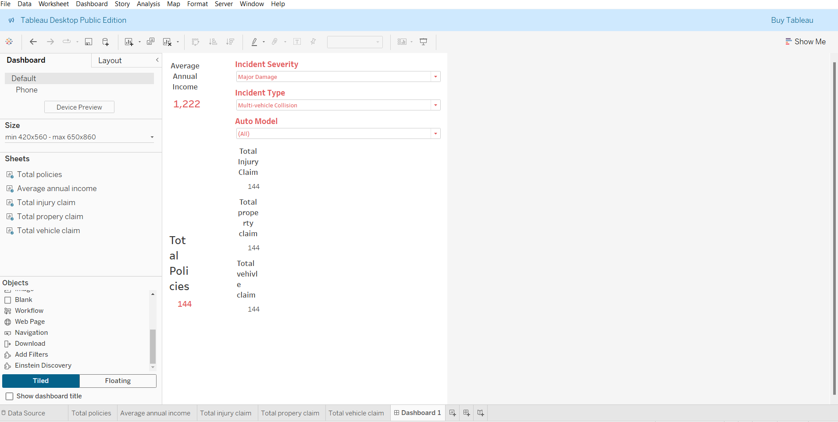

1. Charts:  
   a. Scatter plot which analyses Model wise Capital gain and loss  
   b. Pie chart which shows gender wise percentage bodily injury.  
   c. Side by side chart which shows total type of claims contacted to authority

A.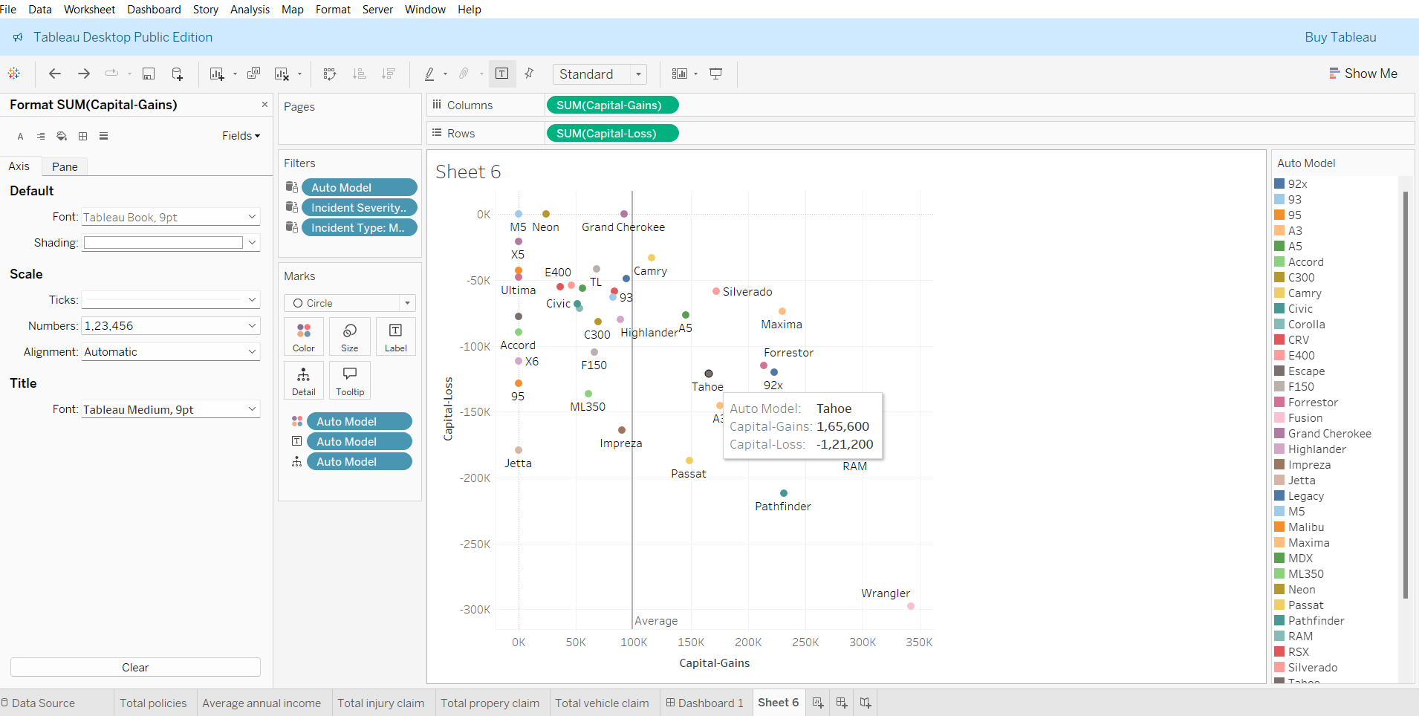

b.

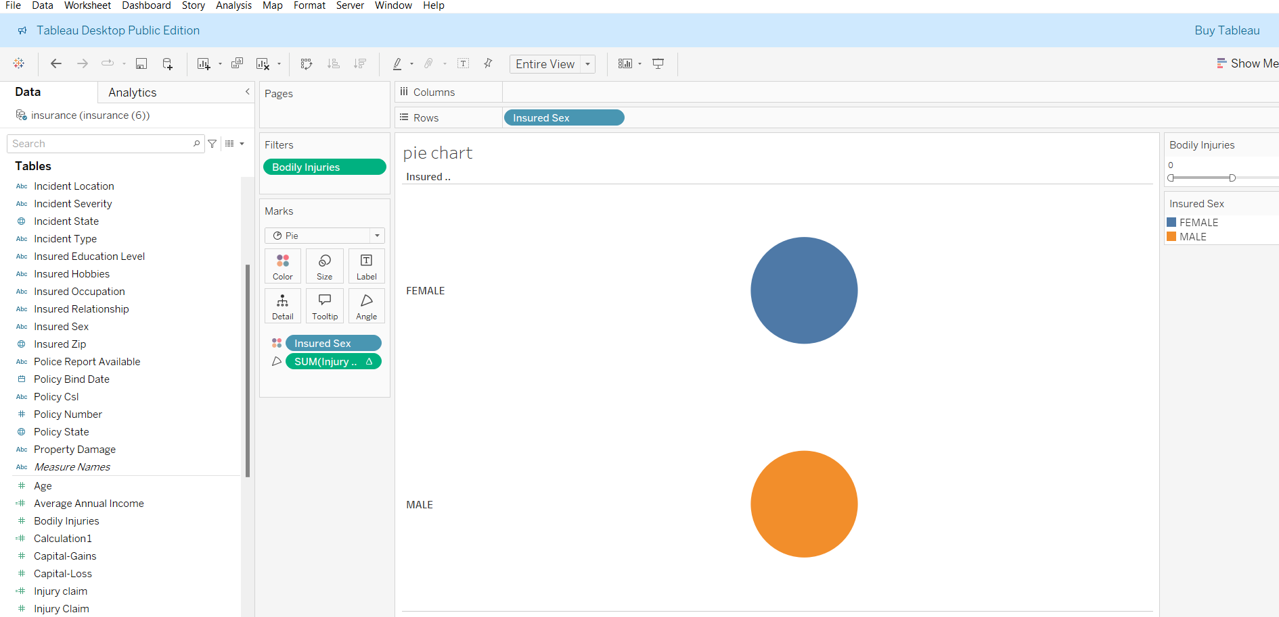

c.

4. Action filters:  
a. Filter action on pie chart which filter out side by side bar chart per gender selection  
b. Go to sheet and highlight action on side-by-side bar chart. After clicking on bar control should shift to 2nd dashboard. In 2nd dashboard respective selected bar data should get highlighted.

a. 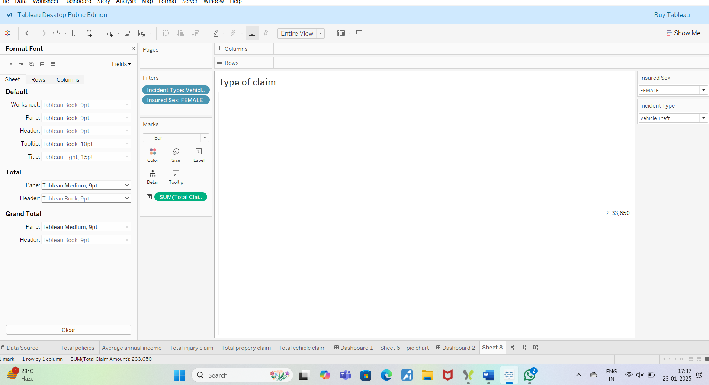

b. 

c.



1. Create title for  dashboard having current date and time.

